SIMATS ENGINEERING
ASSESSMENT TOOL 3: Dataset Integration

COURSE NAME: | Query Processing for Data Science | COURSE CODE: | DSA0503

COURSE OUTCOME COVERED
CO3: Identify and clean inconsistencies in data by handling missing values, duplicates, outliers, formatting issues, and applying techniques like fuzzy matching and regex.

Assessment Tool Weightage: 30%
Total Marks: 20

Code of Conduct
I Anto Chriswin G 192324093 (Name / Reg No) certify that this submission is my original work and that I have adhered to the guidelines specified for this assessment.
I understand that any violation of academic integrity rules will result in disciplinary action.
Signature of the student:


Dataset Integration Rubric

Criteria | Weightage | Level 4 - Exemplary | Level 3 - Proficient | Level 2 - Developing | Level 1 - Beginning
Dataset Understanding & Preparation | 30% | Correctly understands both datasets, identifies relevant columns/keys, and loads them properly. | Minor misunderstanding or preparation issue. | Loads datasets but needs some guidance in identifying relevant fields. | Unable to identify or prepare the datasets correctly.
Dataset Integration | 20% | Correctly integrates datasets using appropriate merge(), join(), or concat() and selects the correct integration key. | Integration is mostly correct with minor errors. | Performs integration with significant guidance or minor key/operation errors. | Unable to integrate the datasets correctly.
Data Processing & Analysis | 15% | Correctly performs all required calculations, filtering, grouping, or transformations on the integrated data. | Performs most required analysis correctly. | Performs basic analysis but misses some required operations. | Analysis is incorrect or incomplete.
Python/Pandas Implementation | 20% | Code is correct, efficient, well-structured, and uses appropriate Pandas functions. | Code works with minor inefficiencies/errors. | Code works partially and requires corrections. | Code contains major errors or does not execute.
Output & Interpretation | 15% | Clearly presents the required output and correctly interprets the results. | Output is correct with limited interpretation. | Output is partially correct or poorly presented. | Output is missing/incorrect and results are not interpreted.

Total Marks Awarded:

Signature of the Course Faculty

Questions:
Set 2 – Dataset Integration Tasks
1. Customer–Order Integration
You are given:
- customer.csv — Customer_ID, Customer_Name, City
- orders.csv — Order_ID, Customer_ID, Order_Date, Order_Amount
Task: Merge the datasets using Customer_ID. Display customer name, city, order date, and order amount. Find the customer with the highest total order amount.
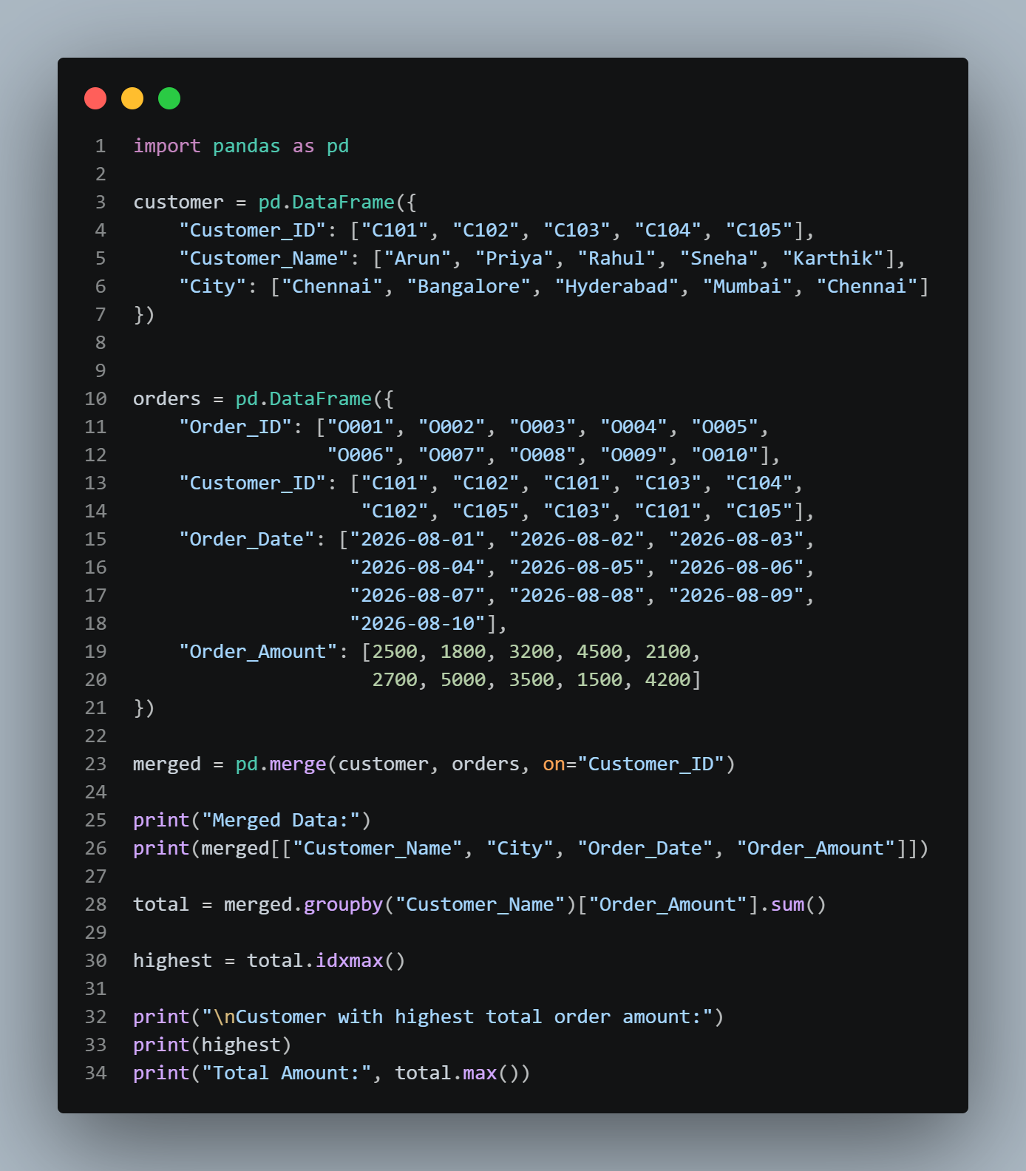

Output :
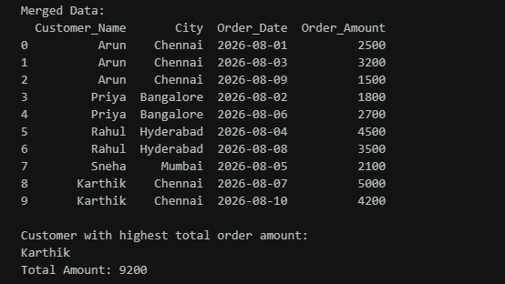

2. Employee–Attendance Integration
You are given:
- employee.csv — Employee_ID, Employee_Name, Department
- attendance.csv — Employee_ID, Date, Status
Task: Integrate the two datasets using Employee_ID. Calculate the number of days each employee was present and absent.
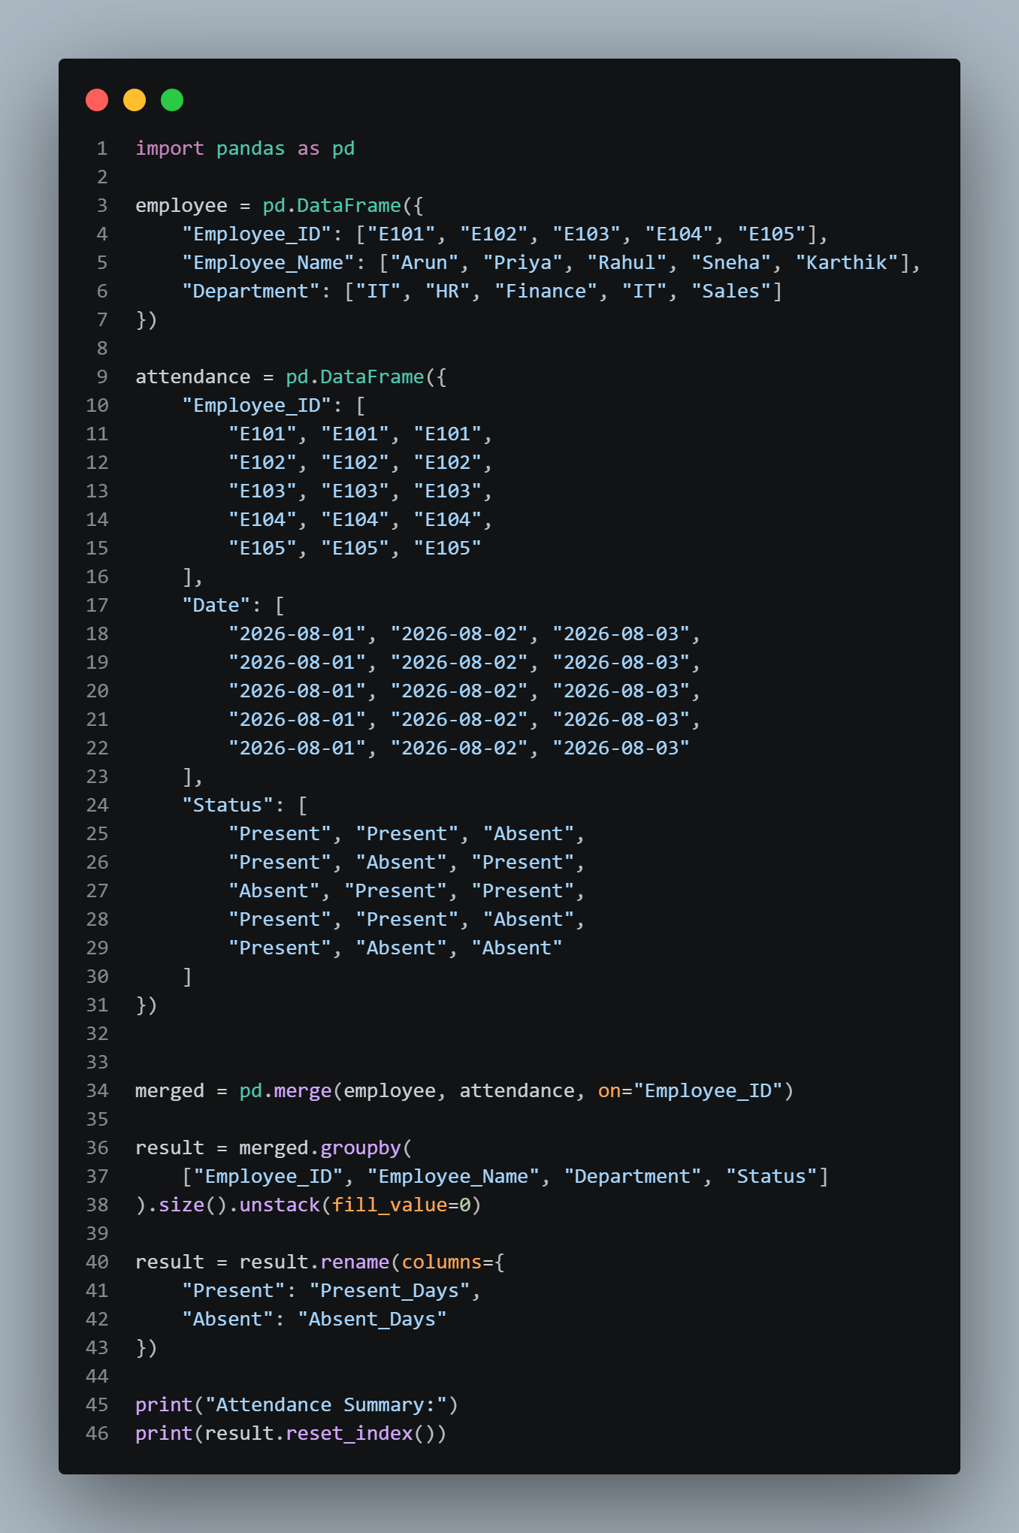
Output :
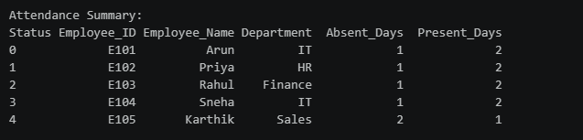

3. Course–Student Integration
You are given:
- students.csv — Student_ID, Student_Name, Department
- enrollment.csv — Student_ID, Course_ID, Course_Name, Credits
Task: Merge the datasets using Student_ID. Display student name, department, course name, and credits. Find the total number of credits registered by each student.
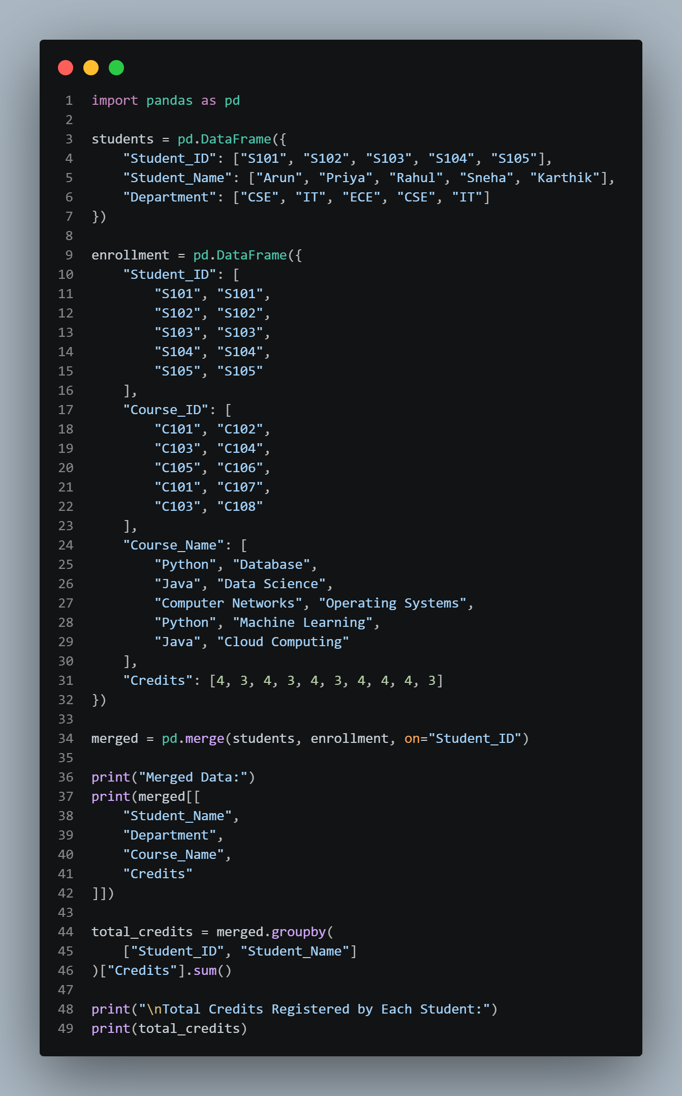

Output:
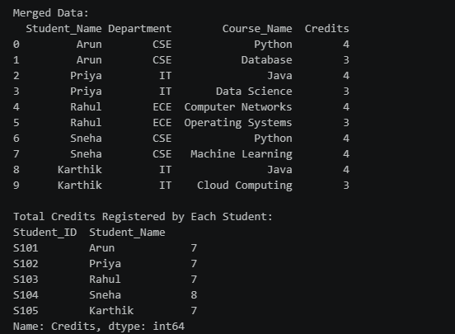
4. Sales–Region Integration
You are given:
- sales.csv — Sale_ID, Product_ID, Region_ID, Quantity, Amount
- regions.csv — Region_ID, Region_Name, Manager
Task: Integrate the datasets using Region_ID. Display the region name, manager, product ID, quantity, and amount. Calculate the total sales amount for each region.
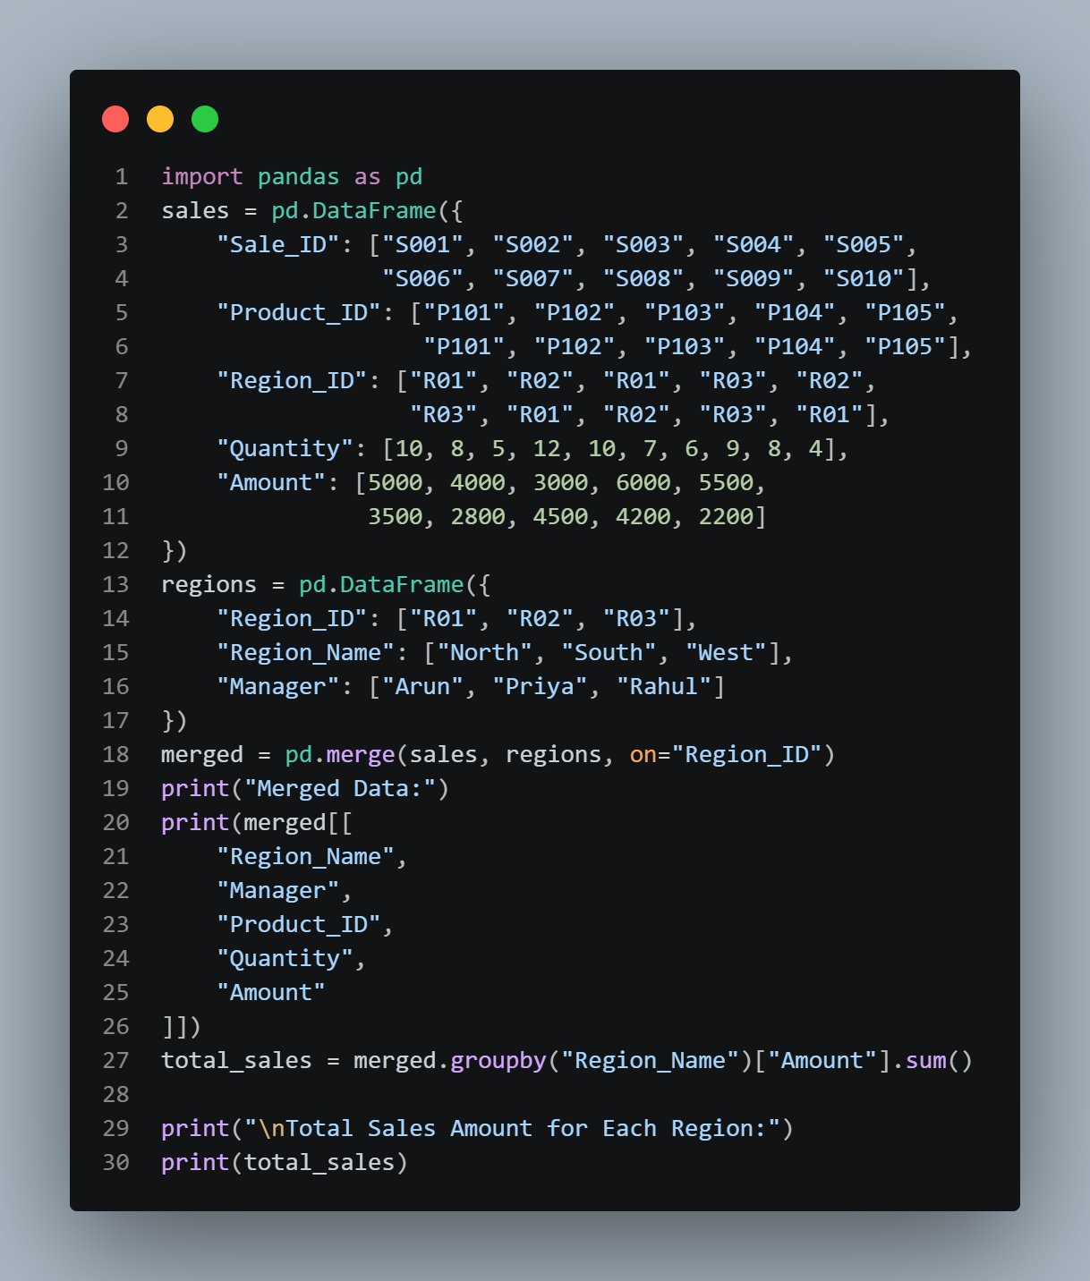
Output:
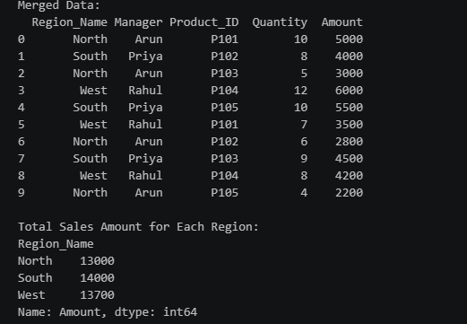
5. Weather–City Integration
You are given:
- cities.csv — City_ID, City_Name, State
- weather.csv — City_ID, Date, Temperature, Humidity, Rainfall
Task: Merge the datasets using City_ID. Display city name, state, date, temperature, humidity, and rainfall. Identify the city with the highest average temperature.
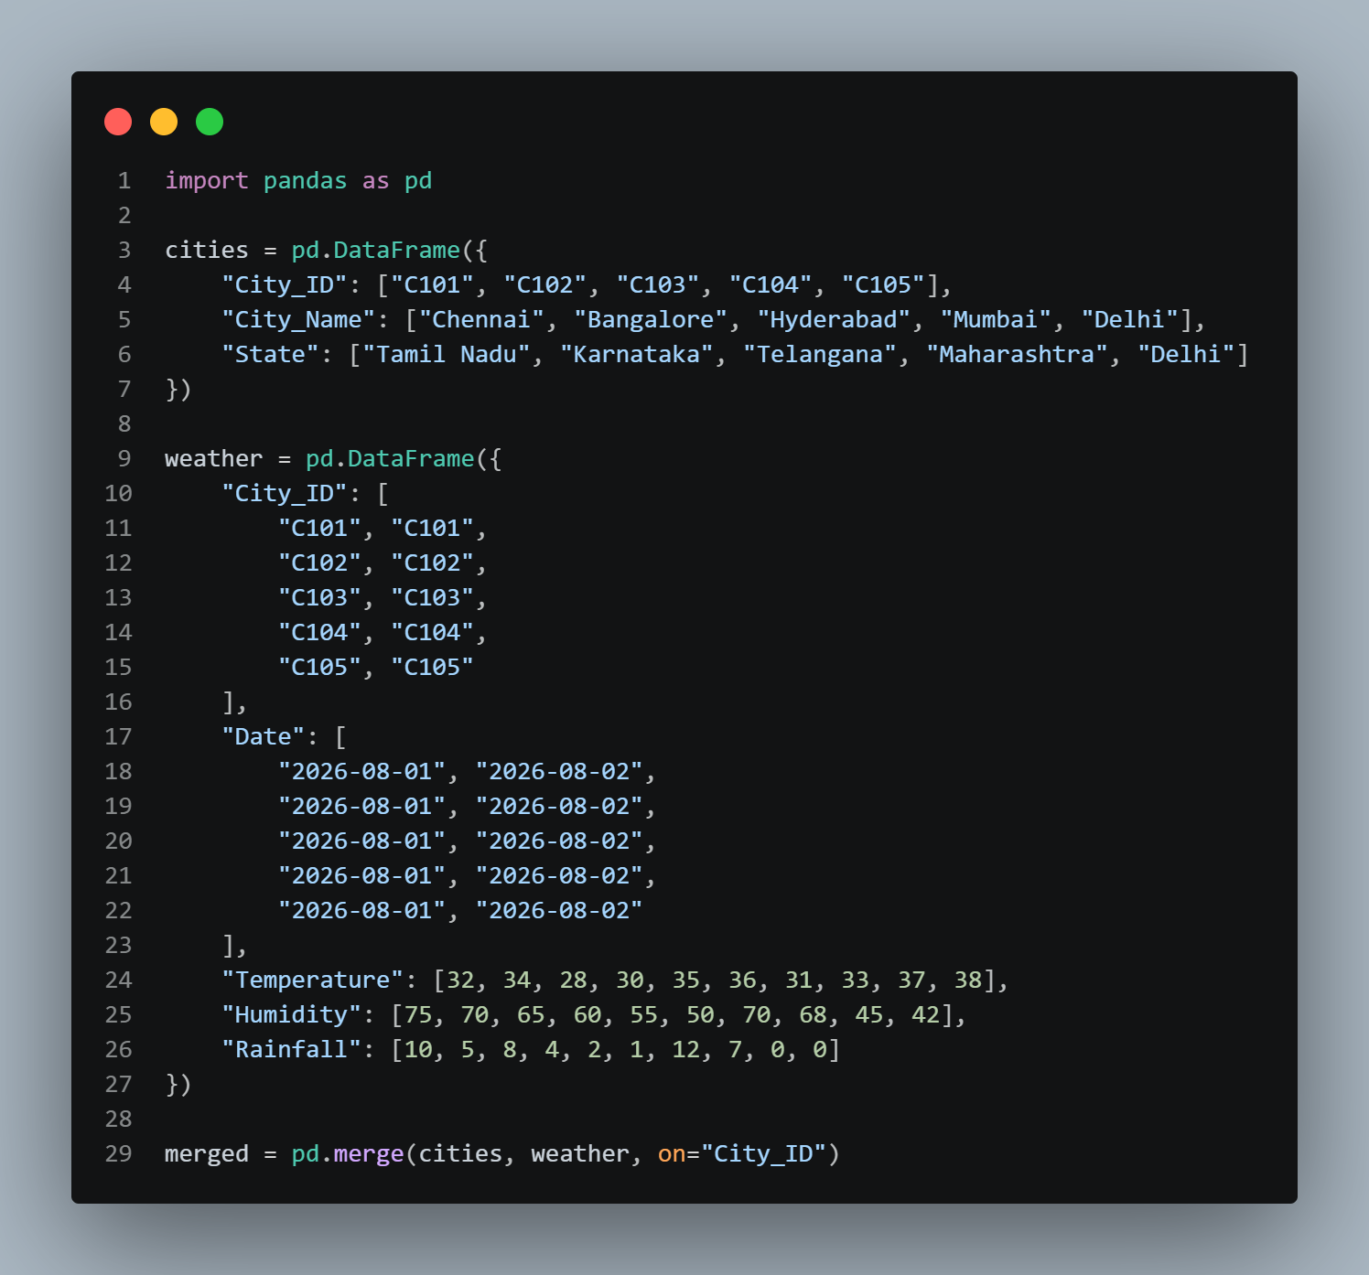
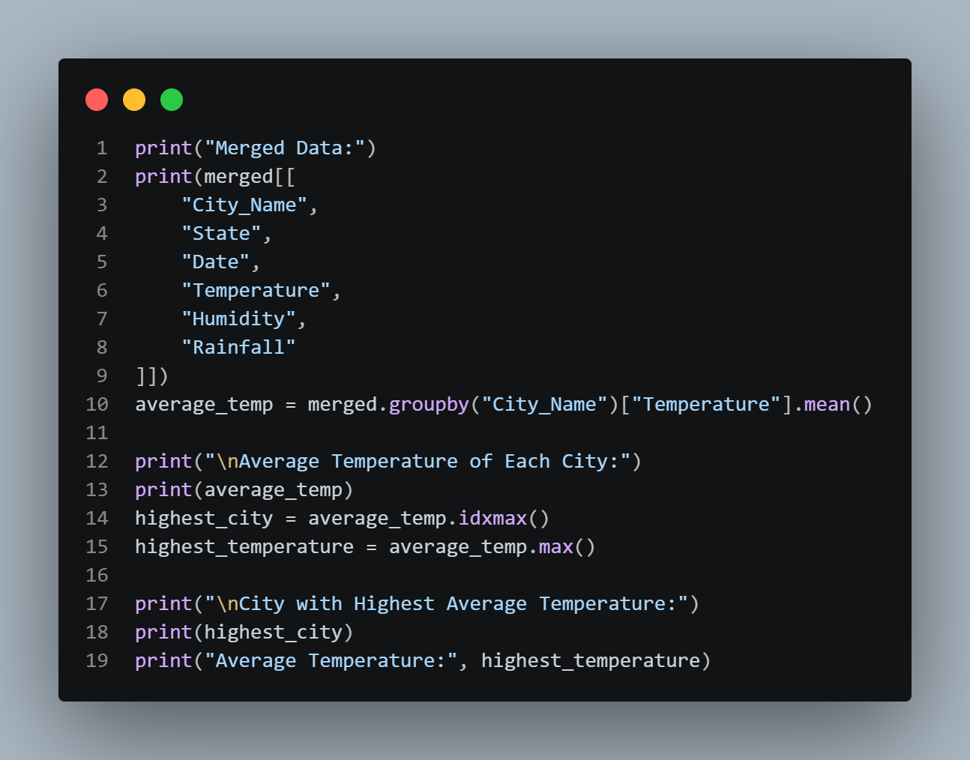

Output:

